Historic Art
Student’s Name
Institutional Affiliation

Historic Art
Hello everyone. My name is Mark Cha and pursues a major in computer science, but I am passionate about art. My passion for art traces back to my formative years when I used to make intelligible drawings. I have a vast collection of artistic works that try to reinforce themes in the modern world. I have attended art exhibitions in different parts of the world, and these are moments that I relish since I have learned about different cultures, histories, and values of diverse communities.
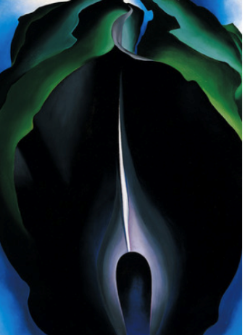
The image is from ”Chapter Introduction” section of the module created by Georgia O’Keeffe (Figure 1-5). I chose the image since it depicts the intricacy of color patterns within plan petals and leaves. The color composition presents a powerful aesthetic characteristic that cannot be seen with bare eyes. I am passionate about the beauty of nature, and the presentation of organic forms using art was more enticing. The art has utilized balance effectively, that makes the painting feel right. The symmetrical arrangement of the color transitions contributes to the balance. In this regard, O'Keeffe uses this element to induce calmness in the viewers. I found it fascinating how the artist has used this art to enhance imagination.

The response is Jasmine Martinez,
Hello Jasmine,
Your post is very insightful. You have articulately explained how you are passionate about art and your thirst to learn about different artistic styles. Find the element of focus used the image interesting since the color choices help viewers to rest their eyes on the essential details that the body is struggling with.
What a great post!
Response to Claudia Varella,
Hello Claudia,
Your post is very insightful. You have articulately explained the element of color in the art. The element of rhythm has been used by the artist to lead the eye from the landscape to the horizon. There are underlying cloudy and hilly shapes that lead to the rhythm.
What a great post!

